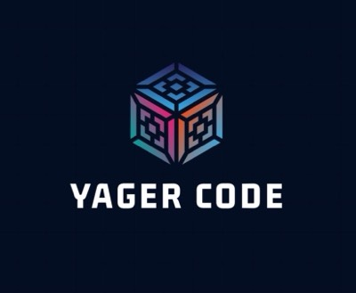
1.About us

Pavel Plamenov Parvanov 9V- Scrum Trainer
Yavor Velizarov Velizarov 9G-Back-end Developer
Bozhidar Hristov Stoyanov 9G- Back-end Developer
Desislav Dimitrov Aleksandrov 9A- Designer

2.Summary
Yager Code is a test administration program that allows users to take tests in subjects like History, Geography, Biology, Math, and Informatics. It tracks performance through various metrics, including average, best, and worst scores, as well as completion times. Additionally, it provides a category breakdown for each subject, highlighting the top and lowest-performing users. By offering detailed insights into individual and overall performance, YagerCode helps users identify their strengths and areas for improvement.
3.Used Technologies
- C++ - programming language for the creation of the app.
- Git hub - for the synchronization of duties and project storage.
- PowerPoint - for the creation of the presentation.
- Word - for the creation of the documentation.
- Microsoft Teams – for communication.

4.Conclusion
The Yager Code program effectively tracks user performance across various subjects, providing insights into both individual and overall performance metrics. This allows users to see where they excel and where they may need improvement.

